Lab: CodePipeline + CodeBuild + CodeDeploy (with Zip Build)
🔧 Pre-Reqs
- An S3 bucket (e.g., my-sampleapp-artifacts)
- A CodeDeploy app (e.g., MySampleApp)
- A deployment group (e.g., MyDeploymentGroup)
- EC2 instances with CodeDeploy agent installed & IAM role configured
- Source repo (GitHub or CodeCommit)

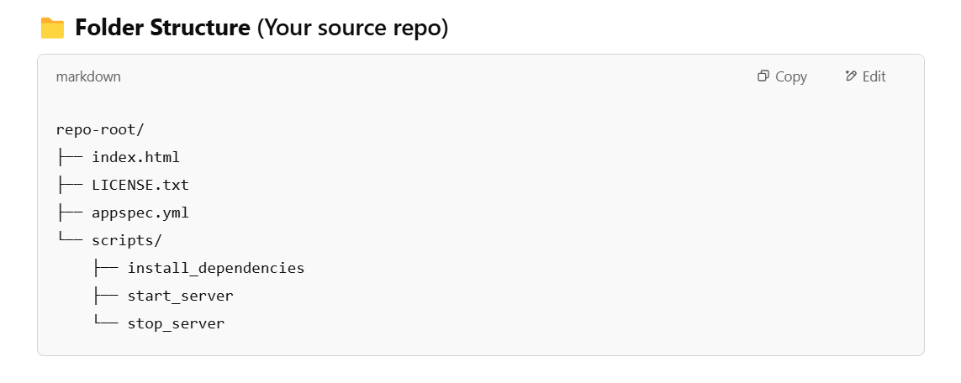
Using an Github link for the same

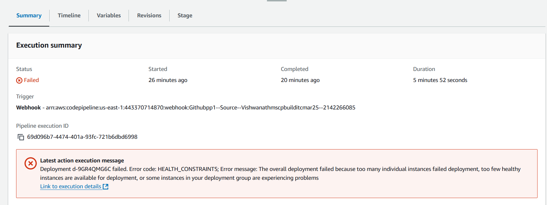
Logged into the s3 bucket
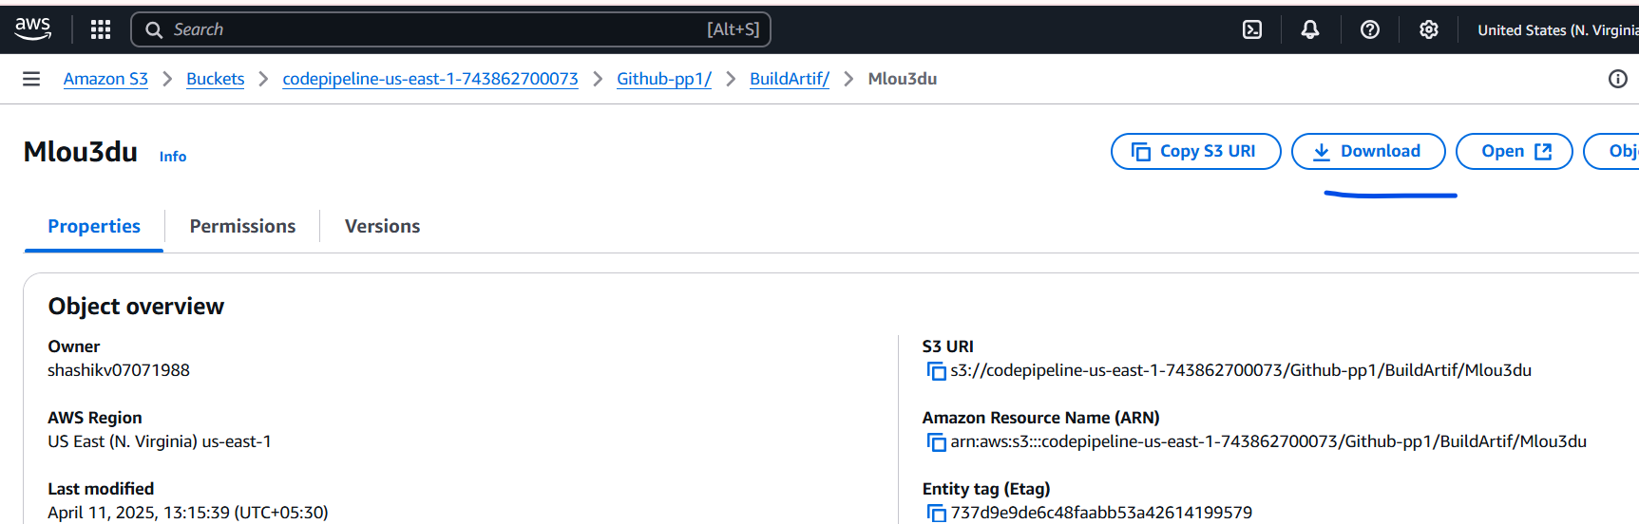
Downloaded the zip file created by the build
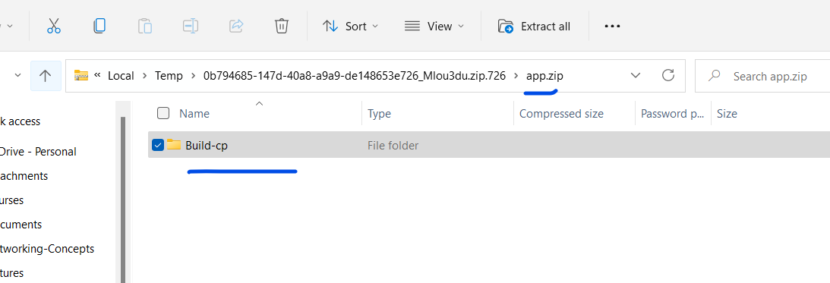
The path is wrong, app.zip should hve the appsec.yaml, but its inside the “Build-cp” folder.
